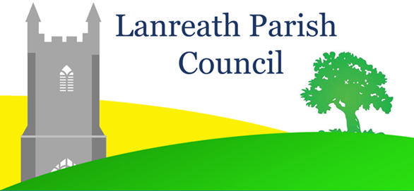

NOTICE OF CO-OPTION

Lanreath Parish Council has vacancies for two Councillors.
To be filled by Co-option.
The Parish Council will consider filling by co-option vacancies for two Councillors at the meeting to be held on 19 March 2024.
Those who are interested in serving the community and want to become a candidate for co-option should complete the application form, available to download from the Parish Council website:
https://www.lanreathparishcouncil.co.uk/lanreath-parish-council/
A paper application form can be obtained from the Parish Clerk.
Applications should be submitted to the Clerk by 5pm on Friday 15 March 2024.
Information on eligibility, the role of the Parish Council and its schedule of meetings may be obtained from the Parish Clerk and from Parish Council website.

Date of notice: 21 February 2024

Rebecca Warren
Parish Clerk and RFO

Applications by mail to: 38 CASTLE STREET, BODMIN, PL31 2DU
or by Email to: clerk2lanreathpc@gmail.com

